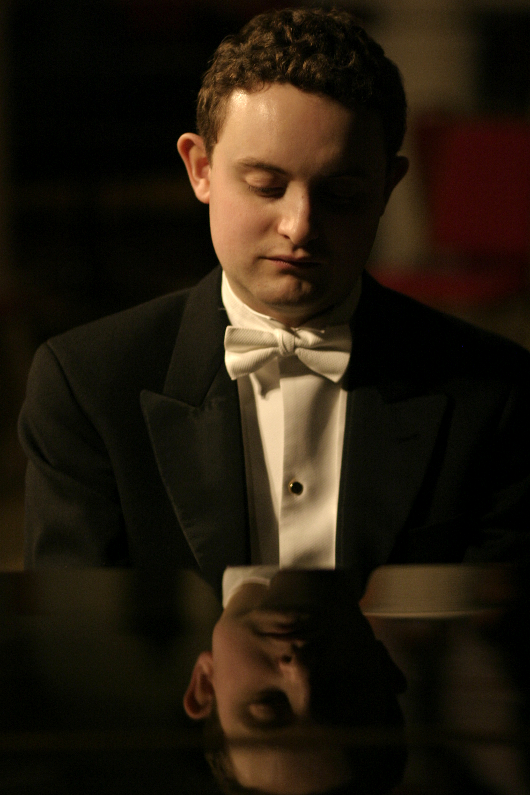
WILLIAM VANN BIOGRAPHY: SHORT

Gramophone, reviewing Purer than Pearl, Albion Records’ latest disc of Vaughan Williams song, reserved “a special word of praise for William Vann’s deft pianism”. A multiple-prize winning conductor and accompanist of growing renown and former pupil of Malcolm Martineau, William performs with a host of major singers and instrumentalists across the world and is the founder and Artistic Director of the London English Song Festival.

Born in Bedford, William was a Chorister at King's College, Cambridge and a Music Scholar at Bedford School. He subsequently read law and took up a choral scholarship at Gonville and Caius College, Cambridge, where he was taught the piano by Peter Uppard, and studied piano accompaniment at the RAM with Malcolm Martineau and Colin Stone.

He has been awarded many prizes for piano accompaniment, including the Wigmore Song Competition Jean Meikle Prize for a Duo (with Johnny Herford), the Gerald Moore award, the Royal Overseas League Accompanists' Award, a Geoffrey Parsons Memorial Trust award, the Sir Henry Richardson Scholarship and the Hodgson Fellowship in piano accompaniment at the RAM. His discography includes recordings with Albion Records, Champs Hill Records, Navona Records and SOMM. Purer than Pearl, Albion’s 2016 release, featured six previously unrecorded songs by Ralph Vaughan Williams.

He is a Trustee of the Ralph Vaughan Williams Society, a Fellow of the Royal College of Organists and a conductor and vocal coach on the Dartington and Oxenfoord International Summer Schools. He is also the Director of Music at the Royal Hospital, Chelsea, where he directs the choir and a programme of concerts in the Royal Hospital's Wren Chapel.

