WILLIAM VANN BIOGRAPHY: FULL LENGTH
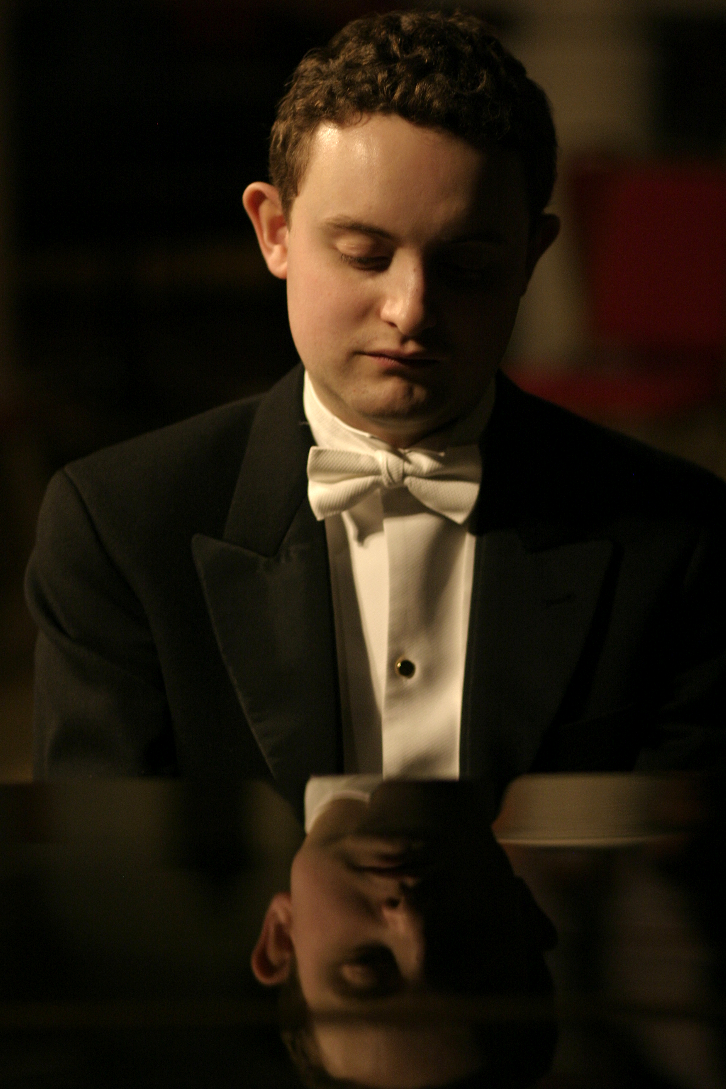

Gramophone, reviewing Purer than Pearl, Albion Records’ latest disc of Vaughan Williams song, reserved “a special word of praise for William Vann’s deft pianism”. A multiple-prize winning conductor and accompanist of growing renown and former pupil of Malcolm Martineau, William performs with a host of major
singers and instrumentalists across the world and is the founder and Artistic Director of the London English Song Festival.

Born in Bedford, William was a Chorister at King's College, Cambridge and a Music Scholar at Bedford School. He subsequently read law and took up a choral scholarship at Gonville and Caius College, Cambridge, where he was taught the piano by Peter Uppard, and studied piano accompaniment at the RAM with Malcolm Martineau and Colin Stone.

He has been awarded many prizes for piano accompaniment, including the Wigmore Song Competition Jean Meikle Prize for a Duo (with Johnny Herford), the Gerald Moore award, the Royal Overseas League Accompanists' Award, a Geoffrey Parsons Memorial Trust award, the Concordia-Serena Nevill Prize, the Association of English Singers and Speakers Accompanist Prize, the Great Elm Awards Accompanist Prize, the Sir Henry Richardson Scholarship and the Hodgson Fellowship in piano accompaniment at the RAM.

William has collaborated on stage with a vast array of singers and instrumentalists, among them Sir Thomas Allen CBE, Mary Bevan, Katie Bray, Allan Clayton, James Gilchrist, Thomas Gould, Johnny Herford, Guy Johnston, Jennifer Johnston, Aoife Miskelly, Ann Murray DBE, Brindley Sherratt, Nicky Spence, Andrew Staples, Kitty Whately and the Benyounes and Navarra Quartets. Recent performances have included appearances at Wigmore Hall, Cadogan Hall, the ROH Crush Room, Sage, Gateshead and St John’s, Smith Square, at the Aldeburgh, Edinburgh, Oxford Lieder, Machynlleth and City of London Festivals, the Northern Ireland Festival of Voice (broadcast on Radio 3) and abroad in France, Germany (on live ZDF television), Ireland, Nigeria, South Africa (National Arts Festival) and Sweden. His discography includes recordings with Albion Records, Champs Hill Records, Navona Records and SOMM. Purer than Pearl, Albion’s 2016 release, featured six previously unrecorded songs by Ralph Vaughan Williams.

In addition to his performances of standard song repertoire, he has also either commissioned or given the first performances of new English songs and song cycles by several English composers, including Christian Alexander, Joseph Atkins, Martin Eastwood, Johnny Herford, Ian Venables, David Nield and Graham Ross (the latter two at Wigmore Hall).

He is a Trustee of the Ralph Vaughan Williams Society, a Samling Artist, a Freeman of the Worshipful Company of Musicians elect, the Co-Chairman of Kensington and Chelsea Music Society, the Artistic Director of Bedford Music Club, a Fellow of the Royal College of Organists and a conductor and vocal coach on the Dartington and Oxenfoord International Summer Schools. He is also the Director of Music at the Royal Hospital, Chelsea, where he directs the choir and a programme of concerts in the Royal Hospital's Wren Chapel, and the founder and Artistic Director of the London English Song Festival, the sixth season of which took place at Wilton’s Music Hall in July 2017.

